Exploring the Process of Mitotic Cell Division
1.1 Introduction
1. You will study mitosis in the Triffle, a mythical creature with six chromosomes that look like knives, forks, and spoons. You will work out each step of the process using paper for cells, yarn for membranes, string for spindle fibers, and plastic knives, forks and spoons for chromosomes.
2. Go through the entire process (1.1 through 1.8) several times, with each group member taking a turn as the "explainer". Follow along with the procedure below for the first one or two turns, and perform the subsequent repetitions from memory. Answer the questions about each stage as you go along, and answer them each time you go through the process. Explain your answers in your own words and your own way -- don't recite them by rote memory.
3. Take one large piece of paper for your cell, and use one color yarn to show the nuclear membrane and a different color yarn to show the cell membrane.
4. Begin with a cell and nucleus containing six chromosomes represented by two forks (one red & one white), two knives (one red & one white), and two spoons (one red & one white). This represents a diploid cell with three pairs of chromosomes (Figure 5).
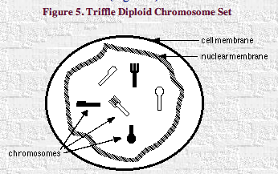
5. What does diploid mean?
b. Are most human cells diploid?
c. How many pairs of homologous chromosomes are present in the picture of a Triffle cell above?
d. Draw a circle around each homologous pair of chromosomes in the picture above.
e. Are the homologues, (a short name for homologous chromosomes) above paired with one another in the cell, or are they independent from one another?
f. What is the best description of homologous chromosomes?
(choose the best response)
(1) they are the same size and shape
(2) they contain the same types of genes in the same order
(3) they generally contain different versions (alleles) of many of their genes
(4) all of the above
g. Define homologous chromosome.
h. Contrast gene and allele.
1.2 Interphase and Chromosome Replication
1. Throughout interphase, the chromosomes are extended and are not visible in the light microscope (Figure 6). That is, the DNA is uncoiled. We cannot simulate this extended condition with the knives, forks, and spoons, so please imagine it. Replicate each of the chromosomes in your Triffle nucleus, pretending they are extended at the time. Do this by obtaining six more chromosomes that match the set you already have. Attach a red fork to your red fork, a white fork to your white fork, and so on with an elastic band (which will represent the centromere). In this process, each chromosome has essentially made an identical copy of itself.
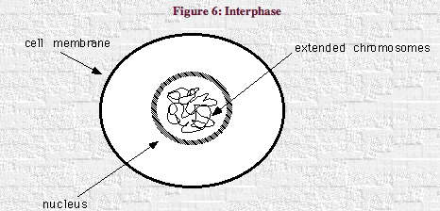
2. Your nucleus initially contained six unreplicated chromosomes, and now it contains six replicated chromosomes. The two identical copies of each chromosome, sister chromatids, remain attached at a point called the centromere (Figure 7).
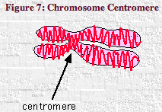
a. What is a chromatid made of (protein, carbohydrate, lipid, and/or DNA)?
b. How do sister chromatids differ from chromosomes?
c. What is the centromere?
d. Contrast extended and condensed chromosomes.

1.3. Prophase of Mitosis
1. In prophase, the replicated chromosomes condense and become visible (Figure 8). This is the first stage of mitosis
a. Are the two sister chromatids that are connected by a centromere identical to one another or do they contain different alleles? Explain.
b. As noted above, these structures are called replicated chromosomes (or, in many books, simply chromosomes). Replicated chromosomes are quite different from the unreplicated chromosomes seen earlier. Compare replicated chromosomes to unreplicated ones (by filling in the blanks below).
(1) the amount of DNA in a replicated chromosome is_____ times the amount of DNA in an unreplicated chomosome
(2) the number of copies of each gene in a replicated chromosome is _____ times the number of copies in an unreplicated chromosome
(3) each replicated chromosome contains _____ (insert number) complete copies of genetic inf
(4) the copies of genetic information in each chromosome are ________________ (identical, homologous, or complementary)
c. Do you think that the homologous replicated chromosomes (the two pairs of knives, the two pairs of forks, and the two pairs of spoons) will pair with one another during mitosis? Explain.
d. How many sister chromatids are in your Triffle nucleus in prophase?

e. A diploid human cell contains 46 unreplicated chromosomes in early interphase. How many sister chromatids will be present in the human cell during prophase of mitosis?

1.4. Prometaphase of Mitosis
1. In prometaphase, the nuclear membrane literally "disappears", which allows the rest of the mitotic events to occur. Remove the nuclear membrane from around the chromosomes in the nucleus of your cell.

2. Spindle fibers form, emanating from two structures called centrioles that have migrated to opposite poles (ends) of the cell. Spindle fibers are assembled from protein microtubules. Put spindle fibers in your cell using pieces of string and draw the centrioles on the paper at the appropriate points.

3. Some of the spindle fibers attach to the replicated chromosomes at their centromeres (Figure 9).
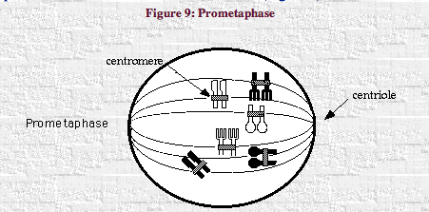

1.5. Metaphase of Mitosis
1. In metaphase, replicated chromosomes are lined up on the metaphase plane (across the center of the cell) by the spindle fibers (Figure 10). Homologous chromosomes are independent of one another. That is, homologous replicated chromosomes such as the two sets of replicated spoons ARE NOT PAIRED.
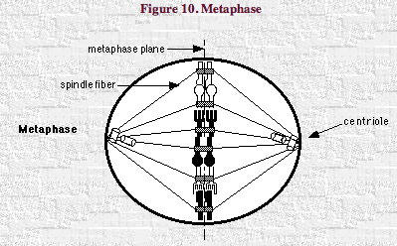
2. Arrange your Triffle chromosomes across the center of the cell. The specific order of chromosomes and their orientation (right side up, upside down) is completely random.
a. How many replicated chromosomes are on the metaphase plane in the Triffle?
b. How many replicated chromosomes would be on the metaphase plane in a human cell undergoing mitosis?

1.6. Anaphase of Mitosis
1. In anaphase, sister chromatids separate to become daughter chromosomes(Figure 11). Separate your sister chromatids to form daughter chromosomes.
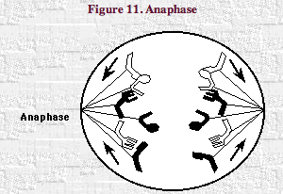
2. Daughter chromosomes are moved toward opposite poles by the spindle fibers. Chromatids are flexible. They do not remain rigid, but rather bend on each side of the centromere as they are dragged through the cytoplasm.

a. Are the daughter chromosomes replicated or unreplicated?
b. Are the two sets of daughter chromosomes, the one moving toward the left and the other toward the right, identical or non-identical?
c. Are the two sets of daughter chromosomes identical to those in the parent cell?
d. What is accomplished by this process?

1.7. Telophase of Mitosis
1. Daughter chromosomes reach the poles of the cell and become extended (relaxed). The spindle fibers disappear ­ actually, the microtubulin subunits are disassembled. You can remove your spindle fibers from your cells and pretend your chromosomes are going into the extended state.

2. Two new nuclear membranes form, one around each set of daughter chromosomes. Use the nuclear membrane yarn to create two new nuclear membranes in your cell (Figure 12). Pinch in the yarn representing the cell membrane.
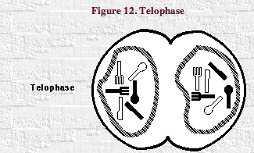

1.8. Cytokinesis
- An animal cell pinches in half at the center (Figure 12), from the outside in, until it has produced two separate daughter cells (Figure 13). Divide your cell in half in this manner by replacing the long yarn representing the parent cell membrane with two shorter pieces of yarn representing the membranes of the two daughter cells.
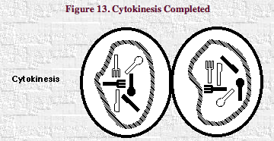

- These daughter cells are now entering the early interphase stage. Pretend that your Triffle chromosomes are becoming extended. The cells will grow to full size and, if continuing to divide, will replicate their chromosomes, and repeat the cycle again.
a. Does the parent cell still exist?
b. How are these daughter cells related to one another?
c. How are these daughter cells related to the parent cell?
d. Overall, what has been accomplished by mitosis?
e. You have used your materials to model mitosis(nuclear division) and cellular division. Explain some ways in which a model differs from the actual things and processes it represents.

1.9. Practice through Repetition
1. As noted above, you can go through the entire process several times, with each group member taking a turn as the "explainer". Follow along with the procedures outlined above for the first one or two turns, and then perform the subsequent repetitions from memory. You may refer to Table 1 for a rough guide, and your team mates can assist you by asking questions and giving hints.

Table 1. Cell Cycle Summary
Interphase
G1 stage | Growth & development  Protein synthesis
S-phase | Chromosome replication via DNA synthesis
G2 stage | Growth & development  Organelle Replication
Mitosis
Prophase | Replicated chromosomes condense
Prometaphase | Nuclear membrane dissolves  Spindle fibers form
Metaphase | Replicated chromosomes align at center
Anaphase | Sister chromatids separate  Daughter chromosomes move to poles
Telophase | New nuclear membranes form  Spindle fibers disappear
Cytokinesis
Cell divides into two daughter cells

Chromosomes in Humans

- Examine the chromosome spread in the top half of Figure 14. How do you think such a picture is obtained?
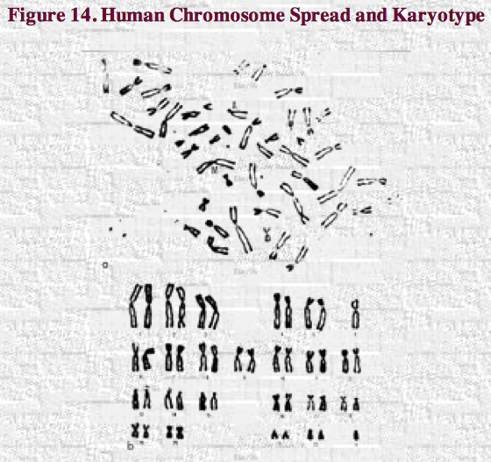

- Then examine the human karyotype in the bottom half of Figure 14. How do you think such a picture is obtained?

- Relate what you have learned in this lab to:
a. the growth and differentiation of tissues in babies,
b. the use of a somatic cell rather than sperm and egg to create a new organism such as a sheep or frog,
c. another related phenomenon of your own choosing.

